Week 13

1. Select all records from module table

The select query written was

SELECT \* FROM MODULE

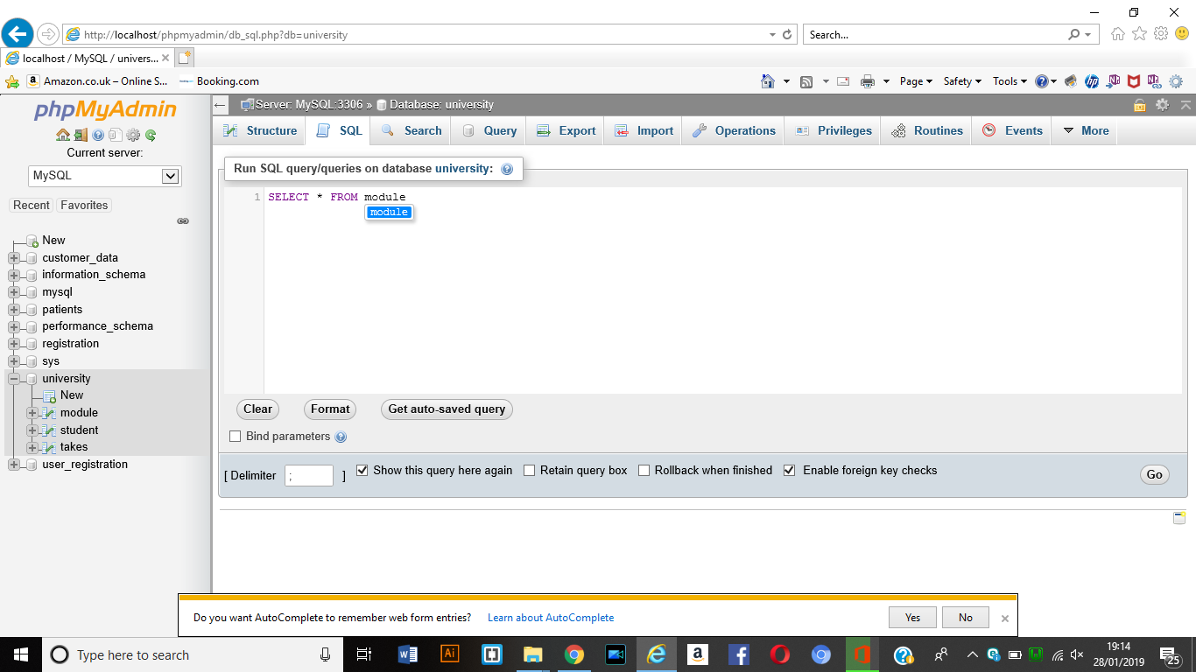

Result

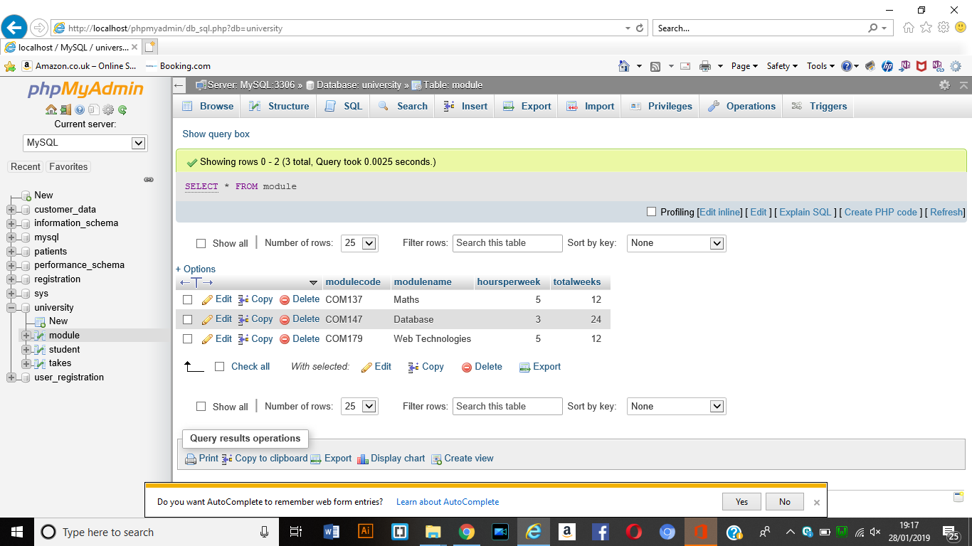

1. Get the module names where hours per week are 5

The Select query

Select ModuleName

From module

Where HoursPerWeek = 5;

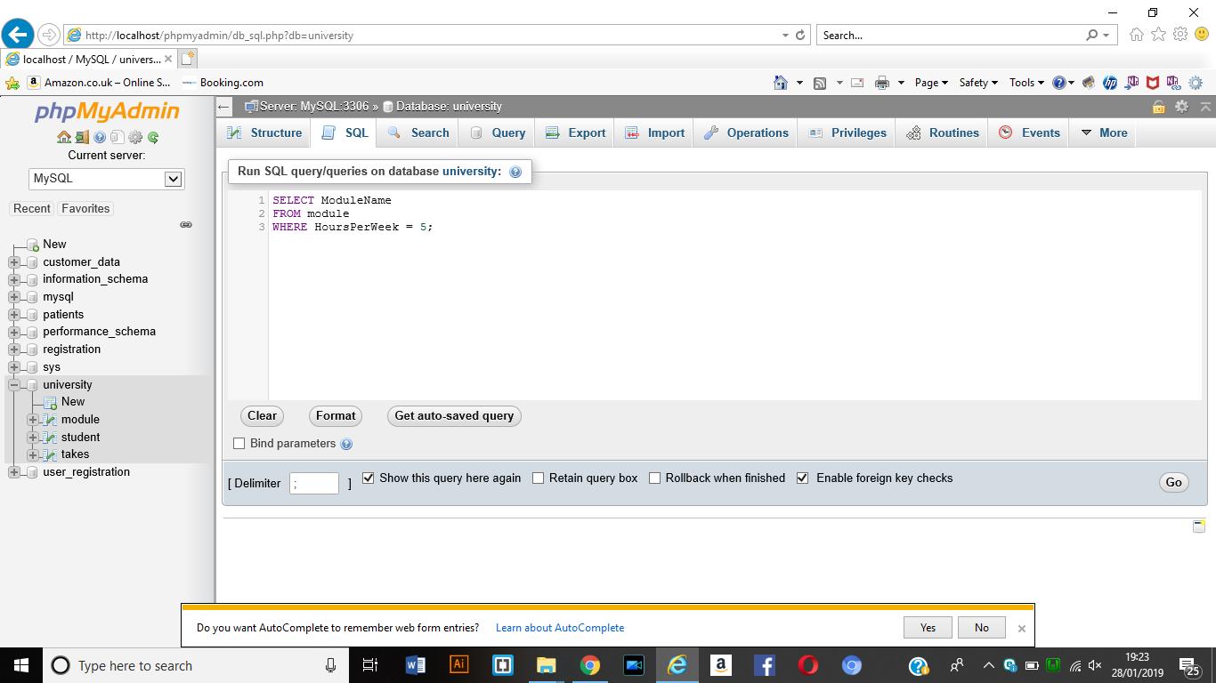

Result

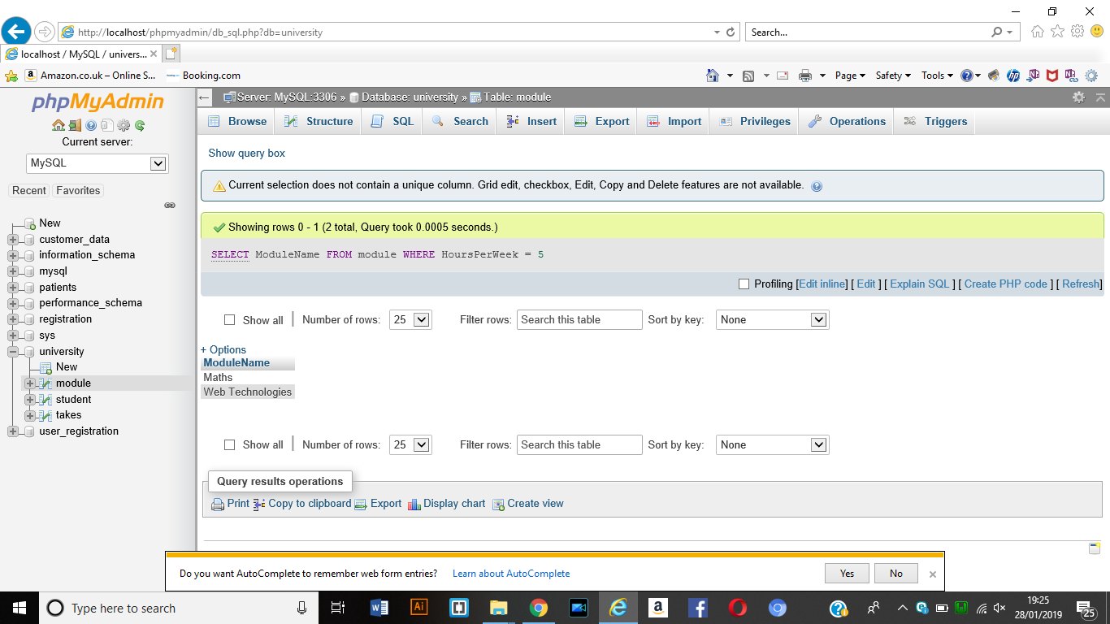

1. Get the full names of students above 18 who are on the BScICT course

SELECT firstname, surname

FROM student

WHERE age > 18

AND coursename = ‘BScICT’;

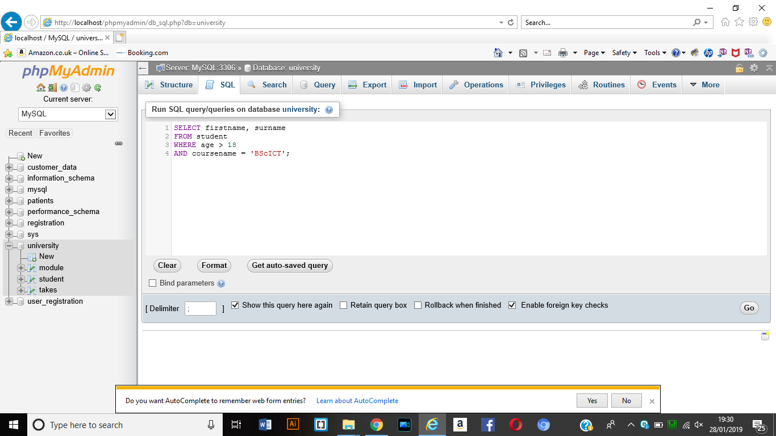

Result

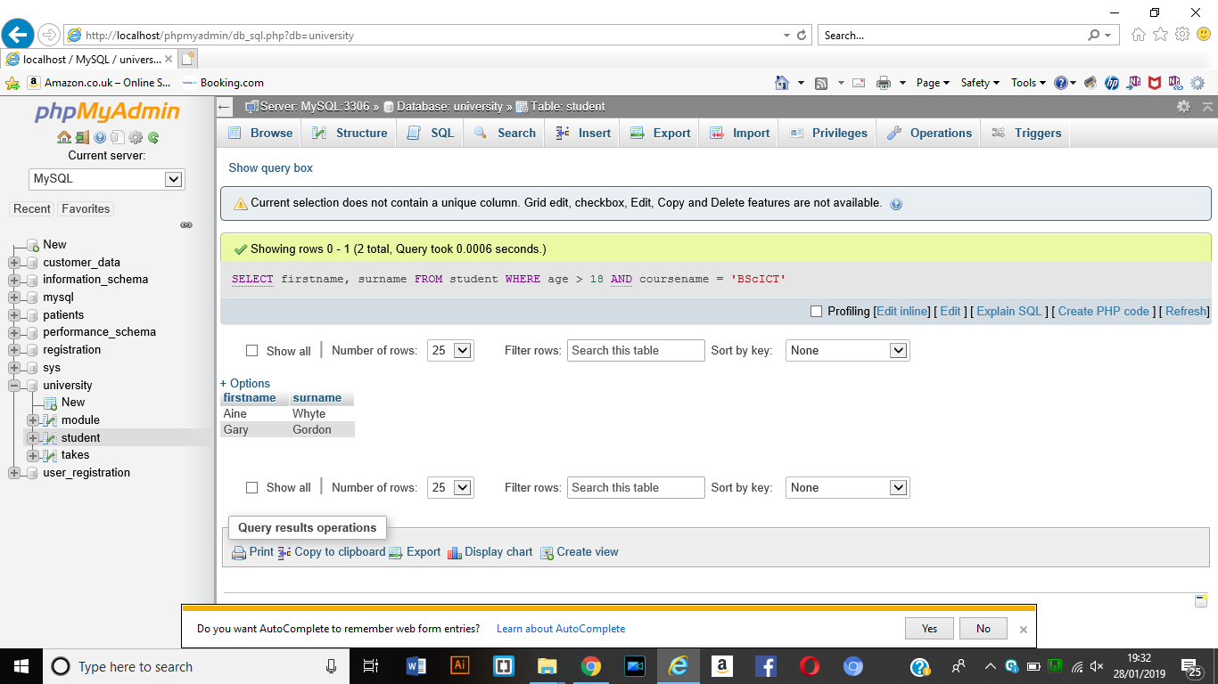

Exercise

1. Get the surnames and emails on the BScCS course

SELECT surname, email

FROM student

WHERE coursename = ‘BScCS’;

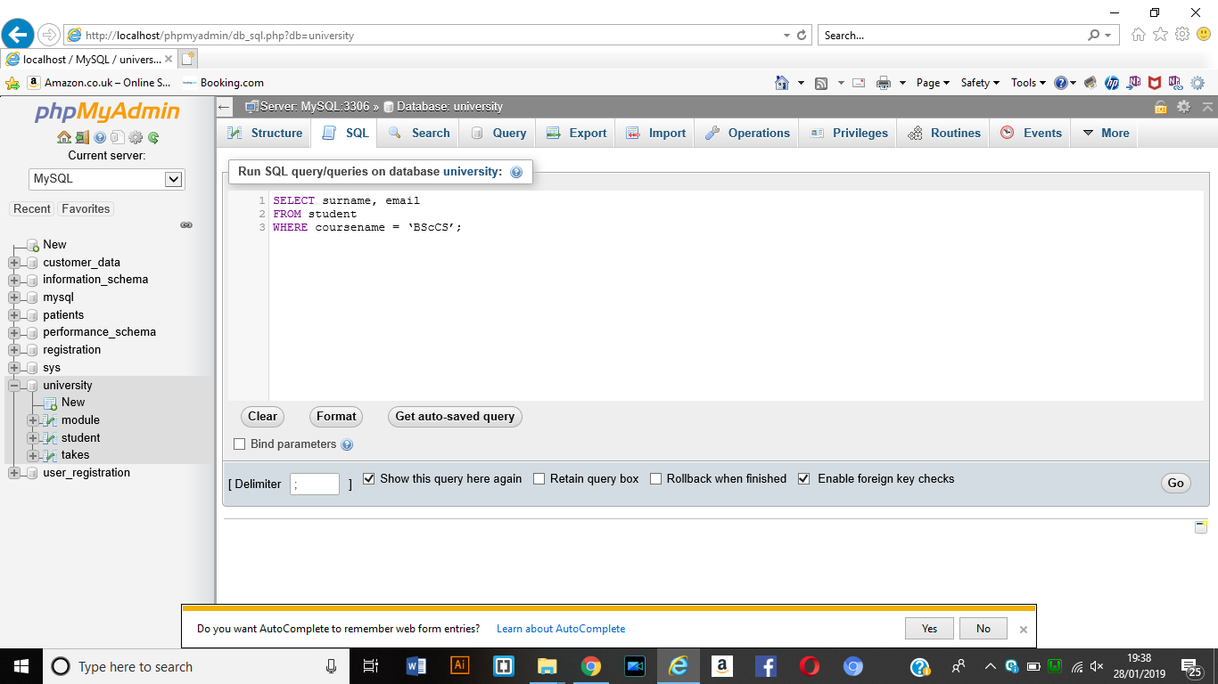

Result

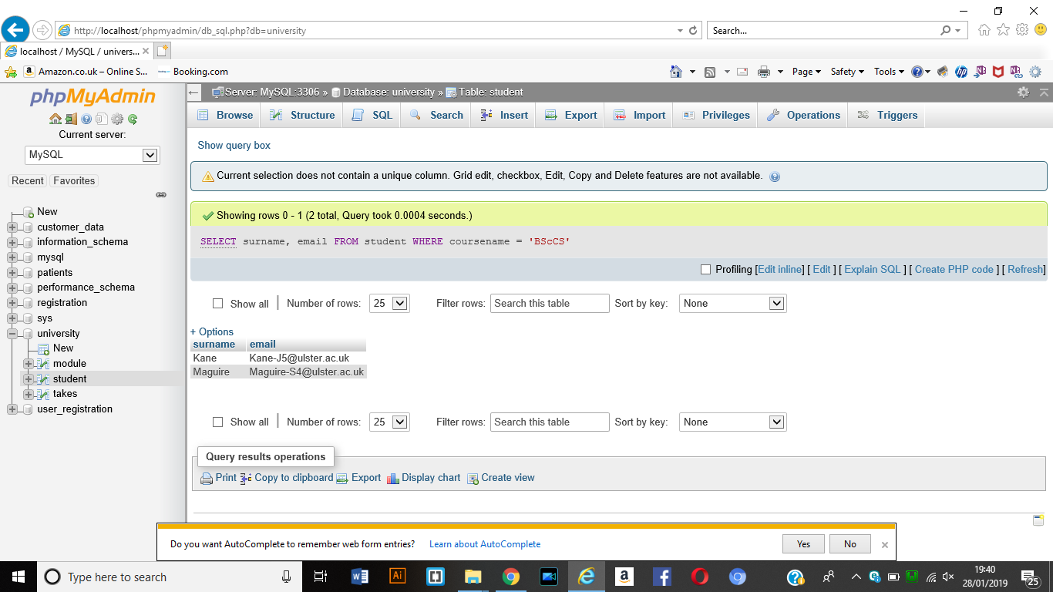

1. Get the module codes of students who got more than 50 in the module mark

SELECT modulecode, studentnum

FROM takes

WHERE modulemark > 50;

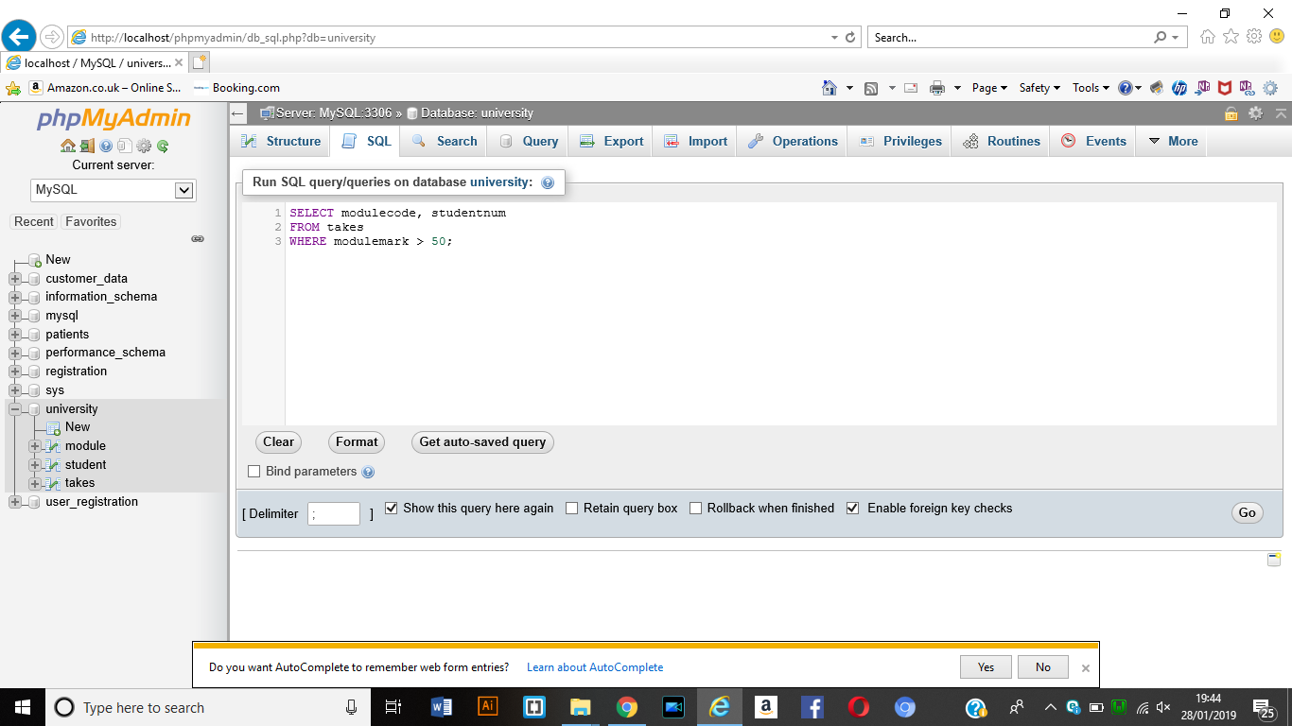

Result

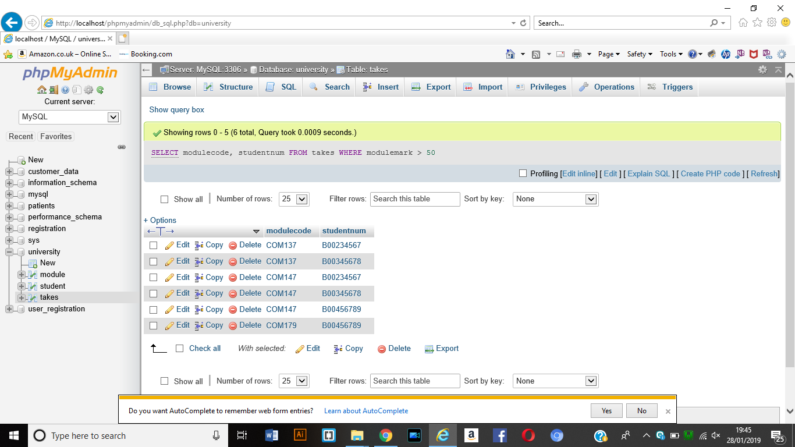

1. Get the Student numbers of students on the module coded COM147 whose coursework mark is below 60.

SELECT studentnum

FROM takes

WHERE modulecode = ‘COM147’;

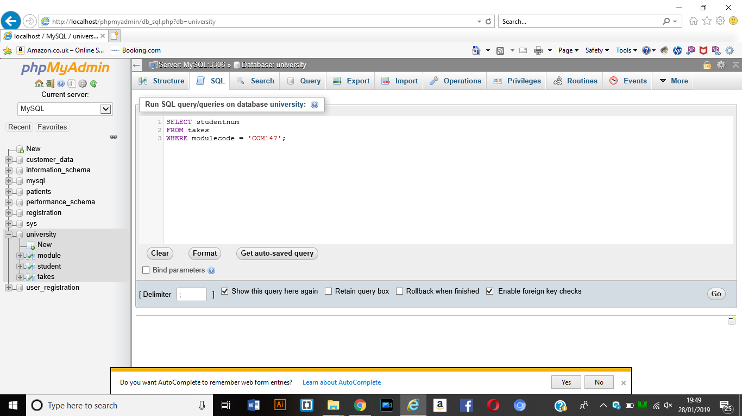

Result

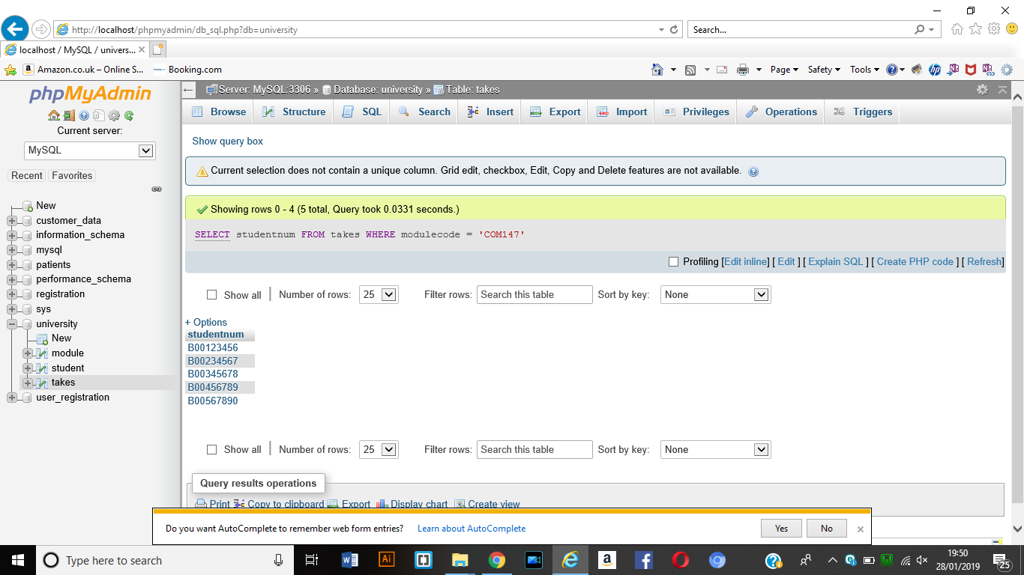

1. Get the firstnames and emails for students aged above 18 and below 21

SELECT firtnames, emails

FROM student

WHERE age > 18 AND age < 21;

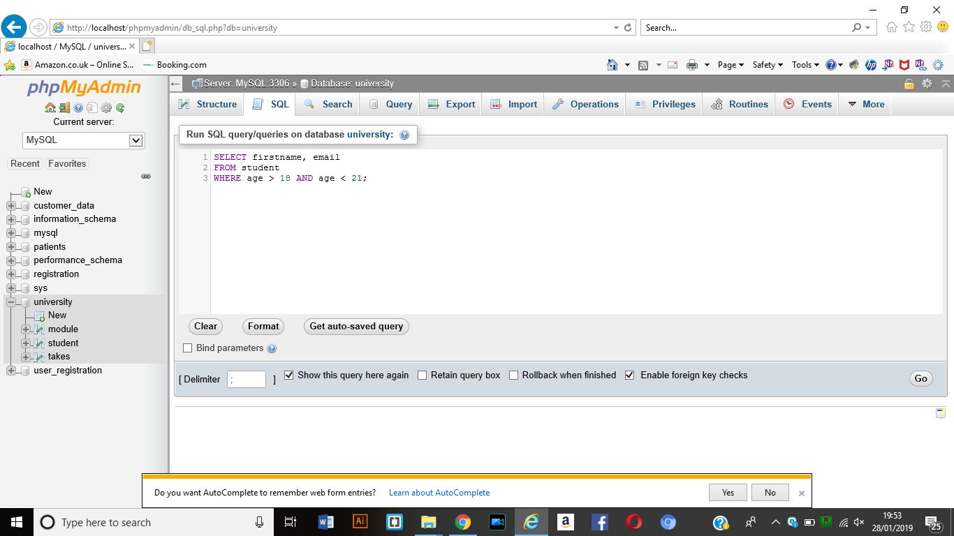

Result

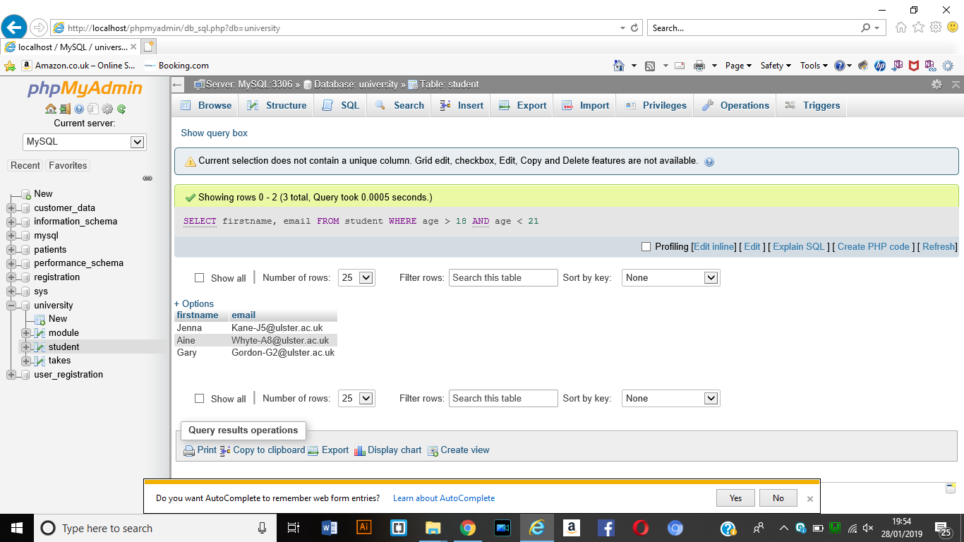

1. Get the Average age of all students

SELECT AVG(age)

FROM student;

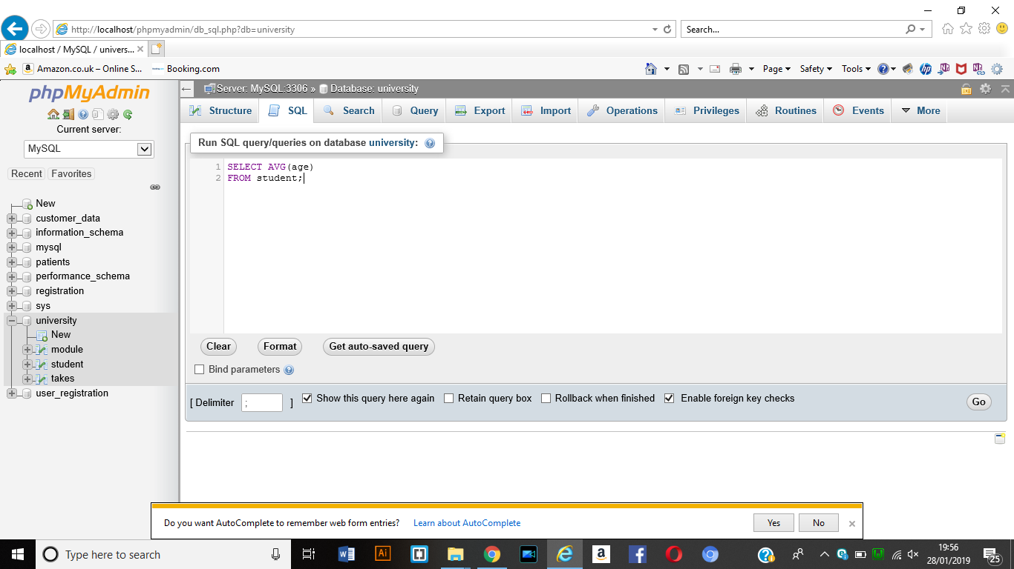

Result

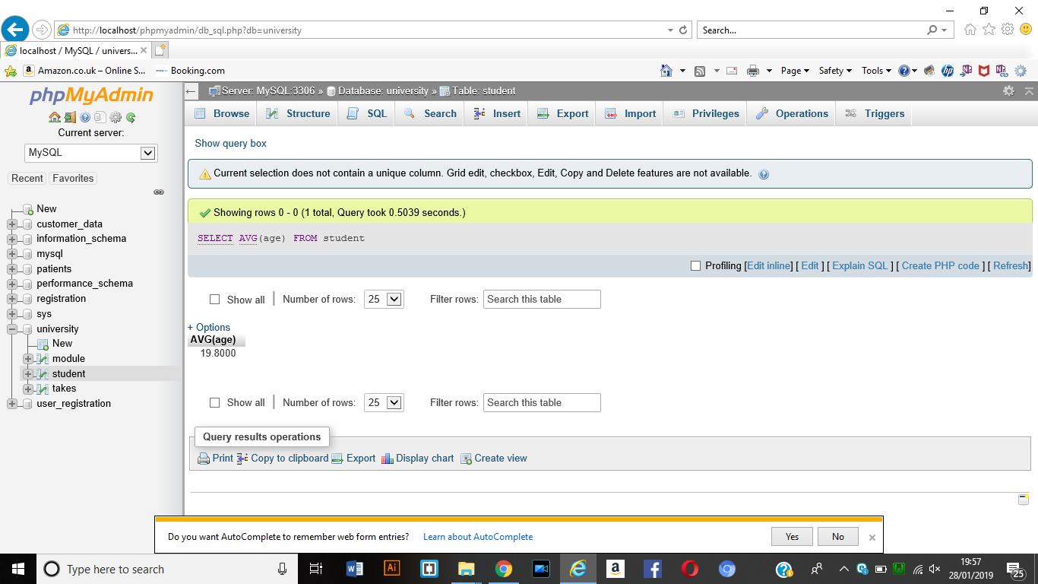

1. How Many modules are there?

SELECT COUNT(ModuleCode)

FROM module;

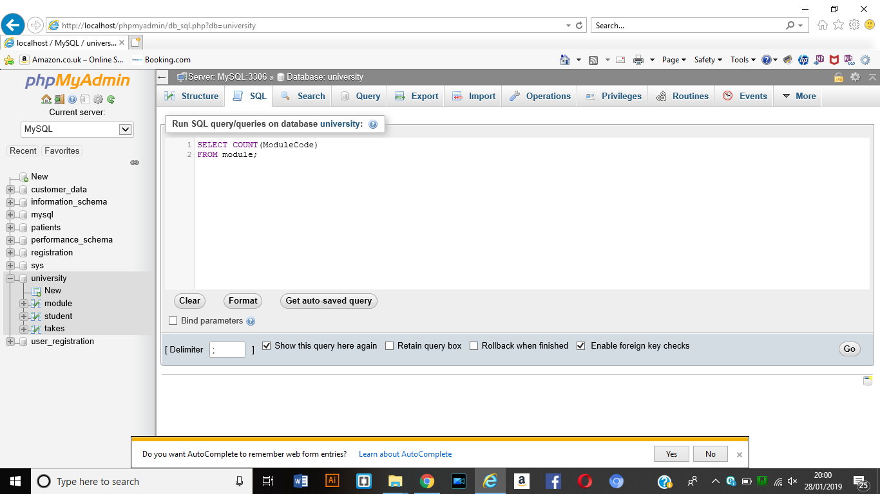

RESULT

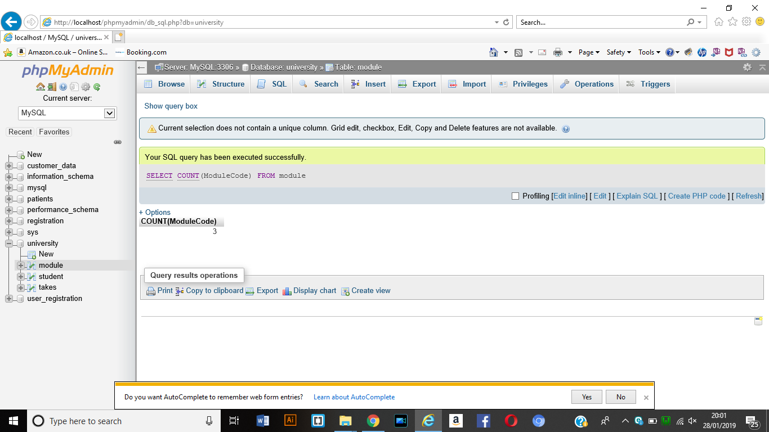

1. How Many Students are on module COM147?

SELECT COUNT(studentnum)

FROM takes

WHERE ModuleCode = ‘COM147’;

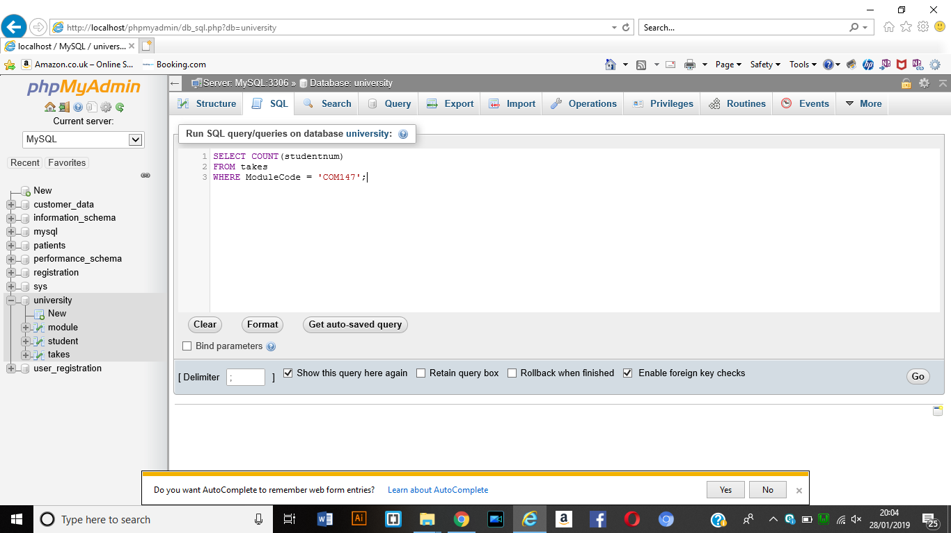

Result

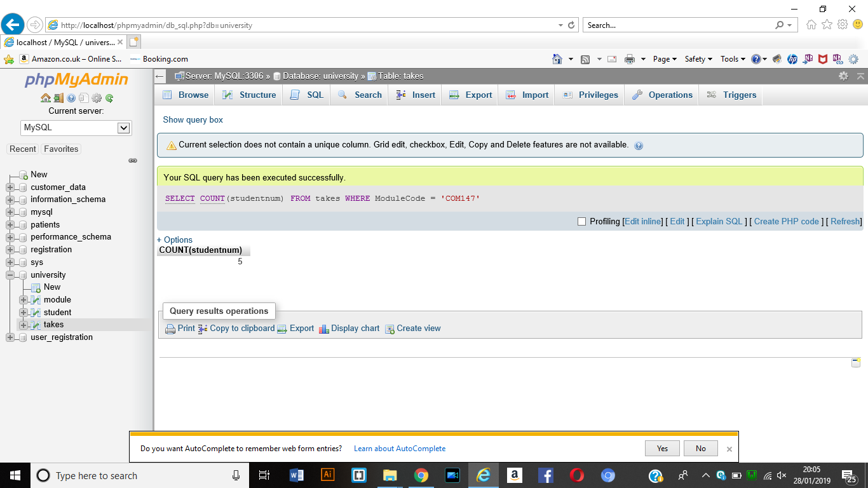

1. Get the names of the module along with the studentnum of students on that module.

SELECT ModuleName, Studentnum

FROM module, takes

WHERE module.ModuleCode = takes.ModuleCode;

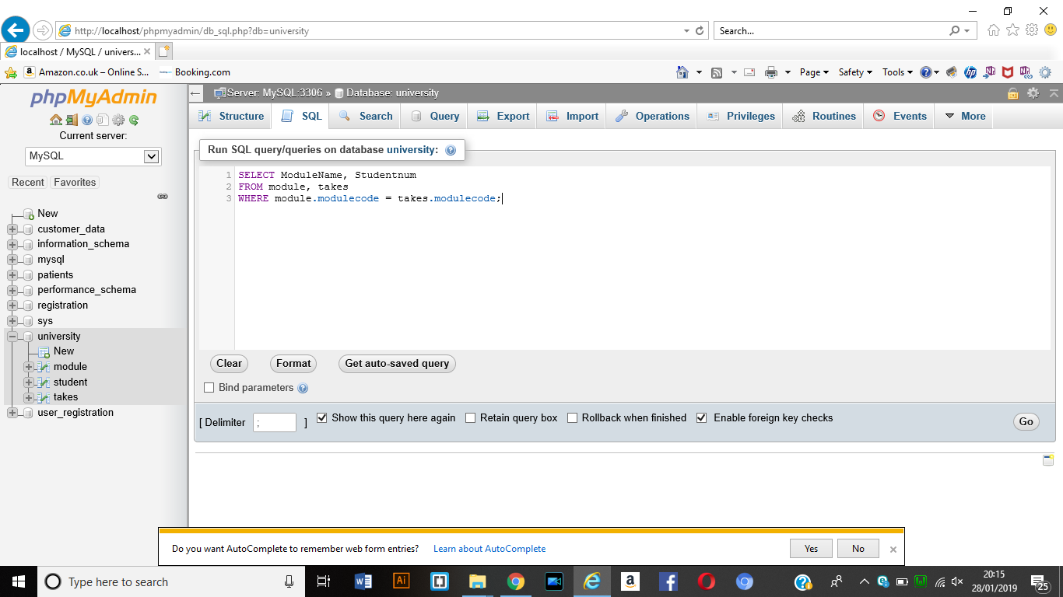

Result

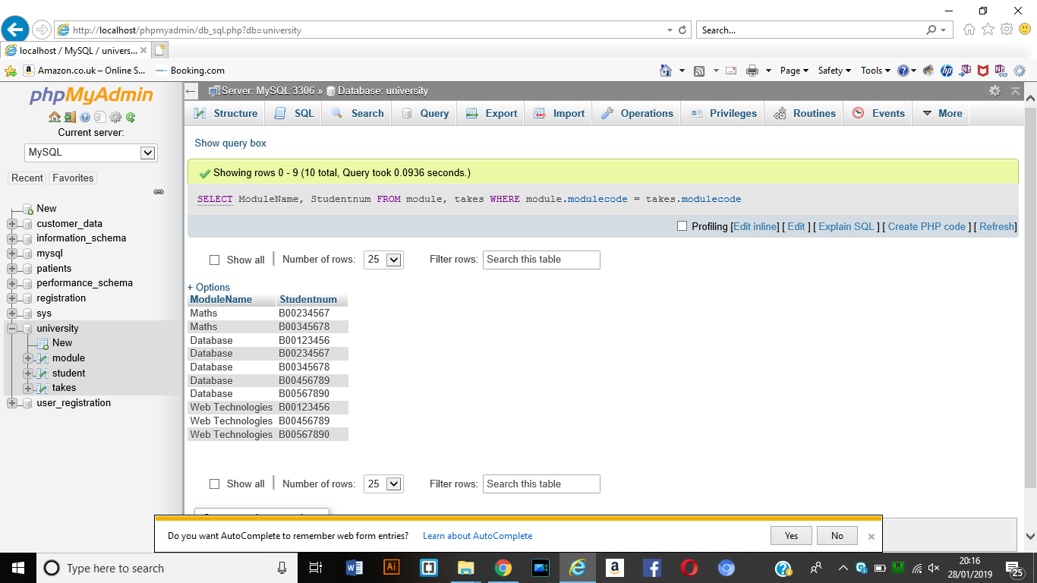

1. Get the names of Students with the names of their module and their module mark for students who got a module mark above 60.

SELECT Surname, ModuleName, ModuleMark

FROM Student, Takes, Module

WHERE student.Studentnum = takes.Studentnum

AND takes.ModuleCode = Module.ModuleCode

AND ModuleMark > 60;

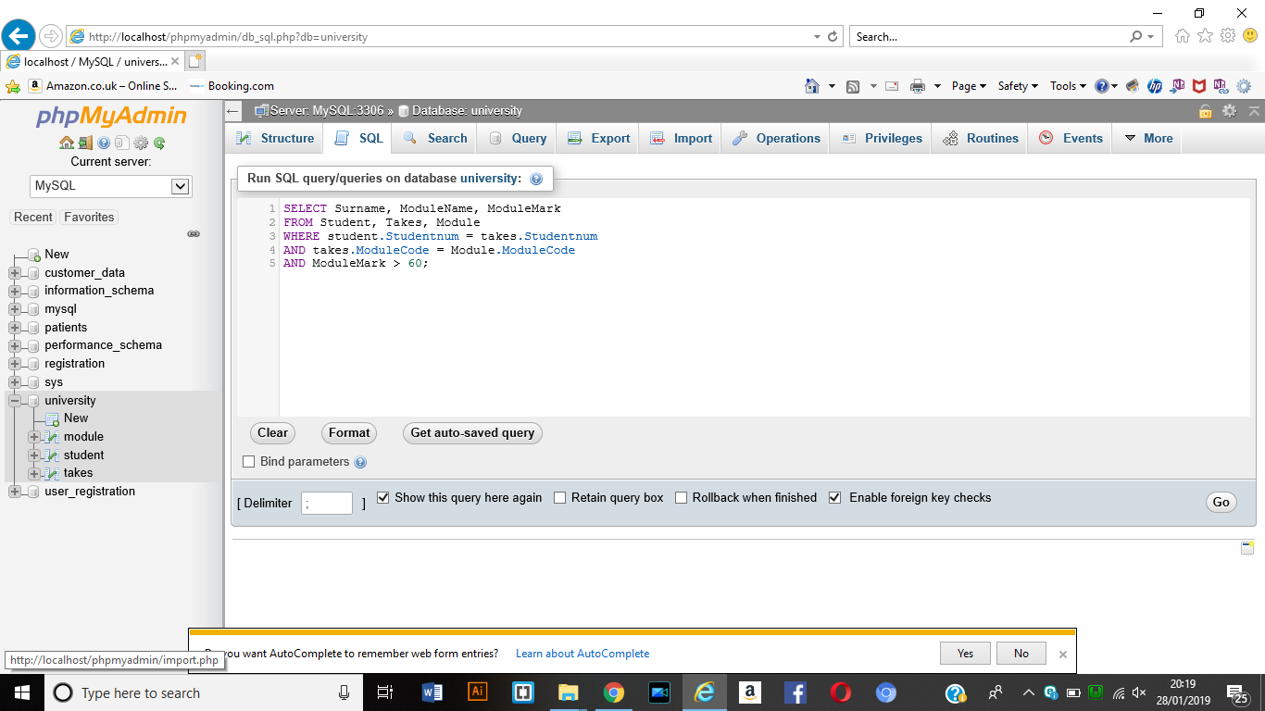

Result

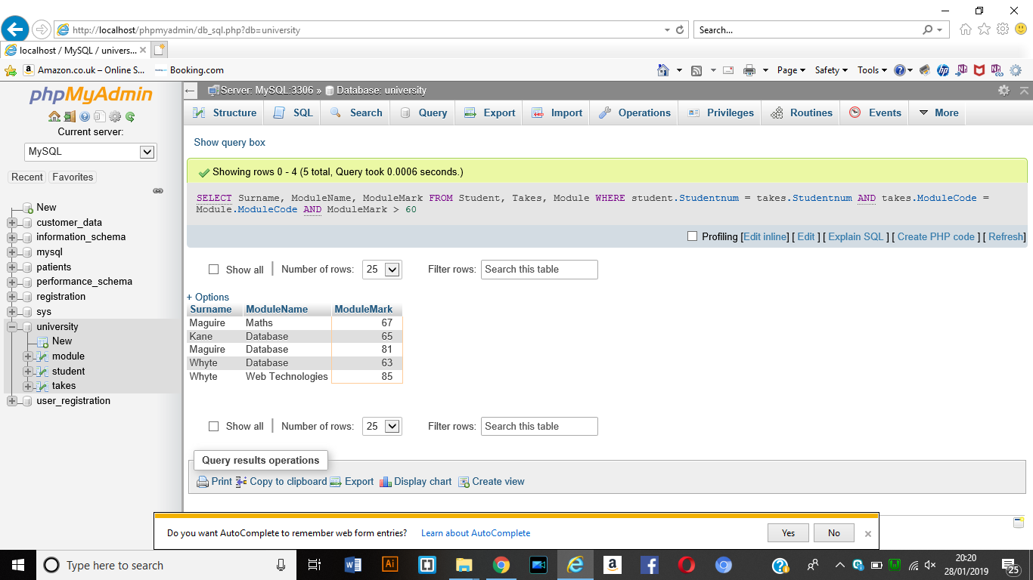

1. Get the names and the hours per week of modules taken by student number ‘B00456789’

SELECT ModuleName, HoursPerWeek

FROM module, takes

WHERE studentnum = ‘B00456789’

AND Module.ModuleCode = takes.ModuleCode;

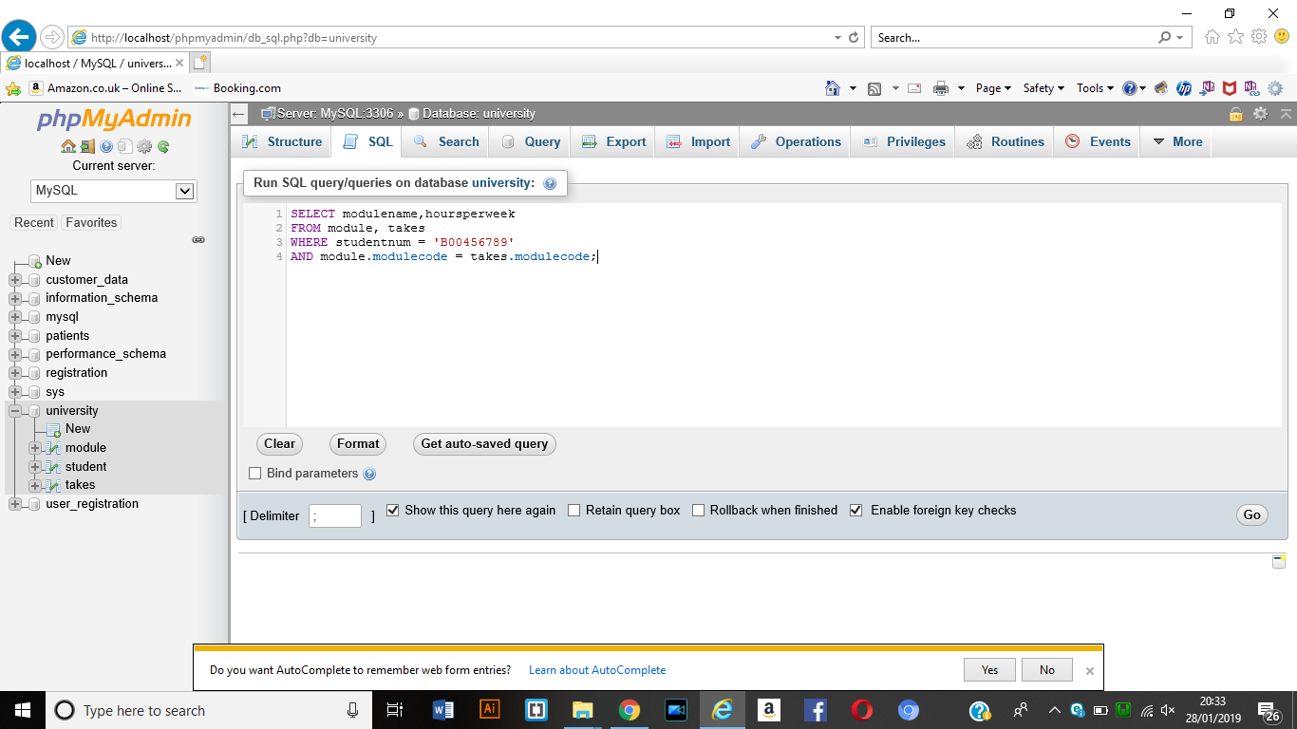

Result

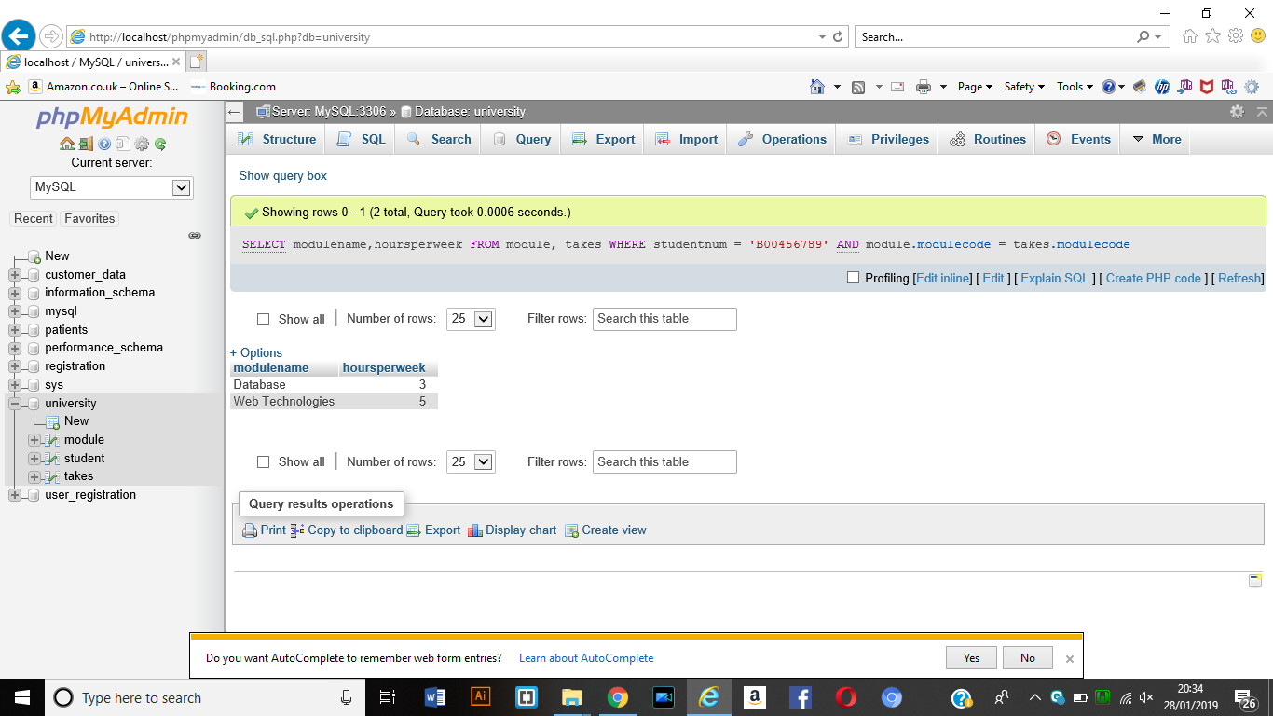

1. Get the names of students who takes modules that run for a total of 12 weeks

SELECT firstname, surname

FROM student, takes, module

WHERE totalweeks = 12

AND student.studentnum = takes.studentnum

AND takes.modulecode = module.modulecode;

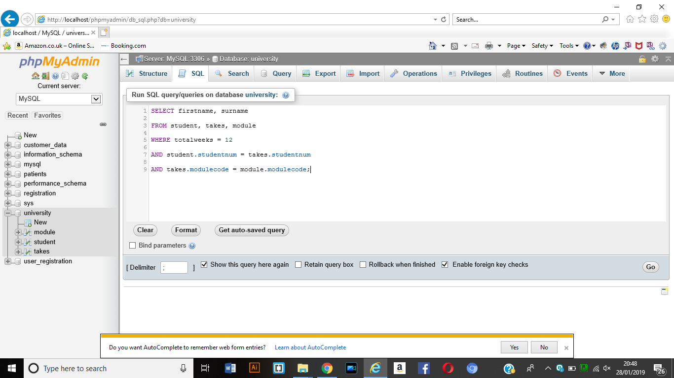

Result

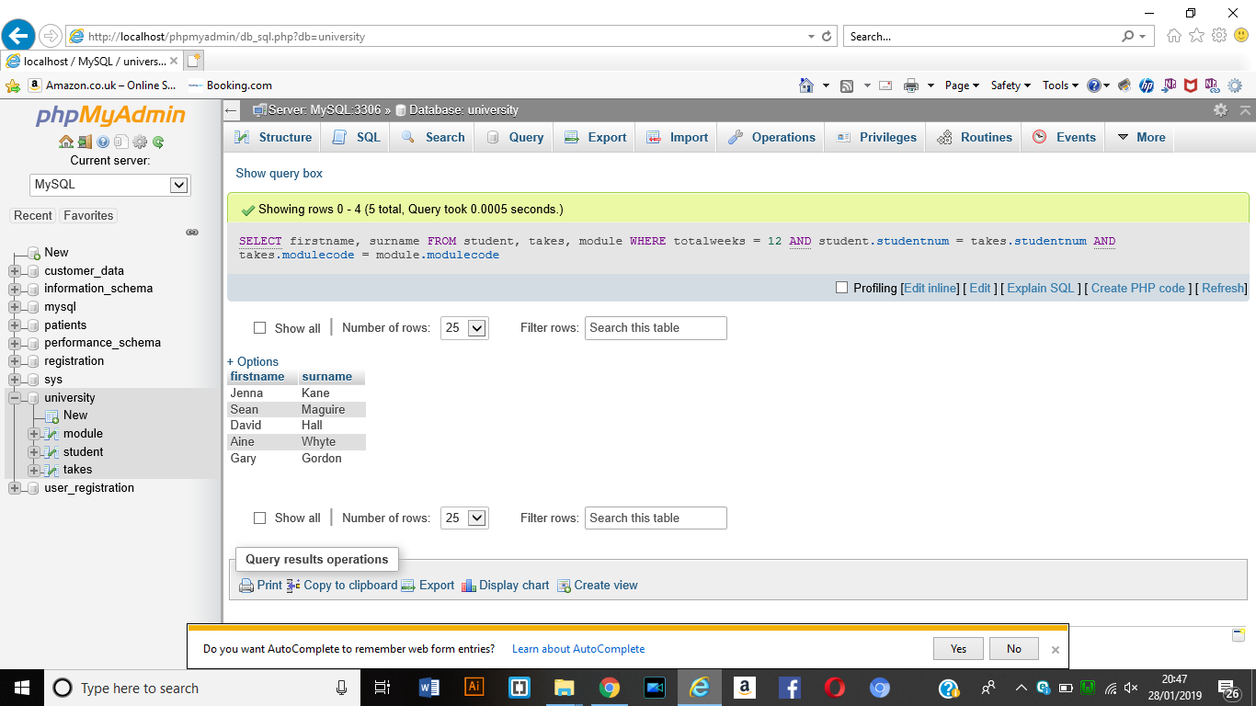

1. Get module name, which has the number of students over three.

SELECT modulename

FROM module, takes

WHERE module.modulecode = takes.modulecode

Group by module.modulecode

HAVING COUNT(studentnum) > 3;

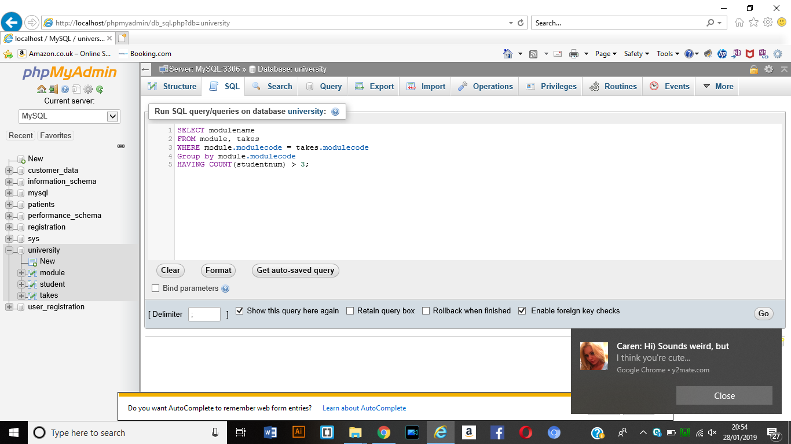

Result

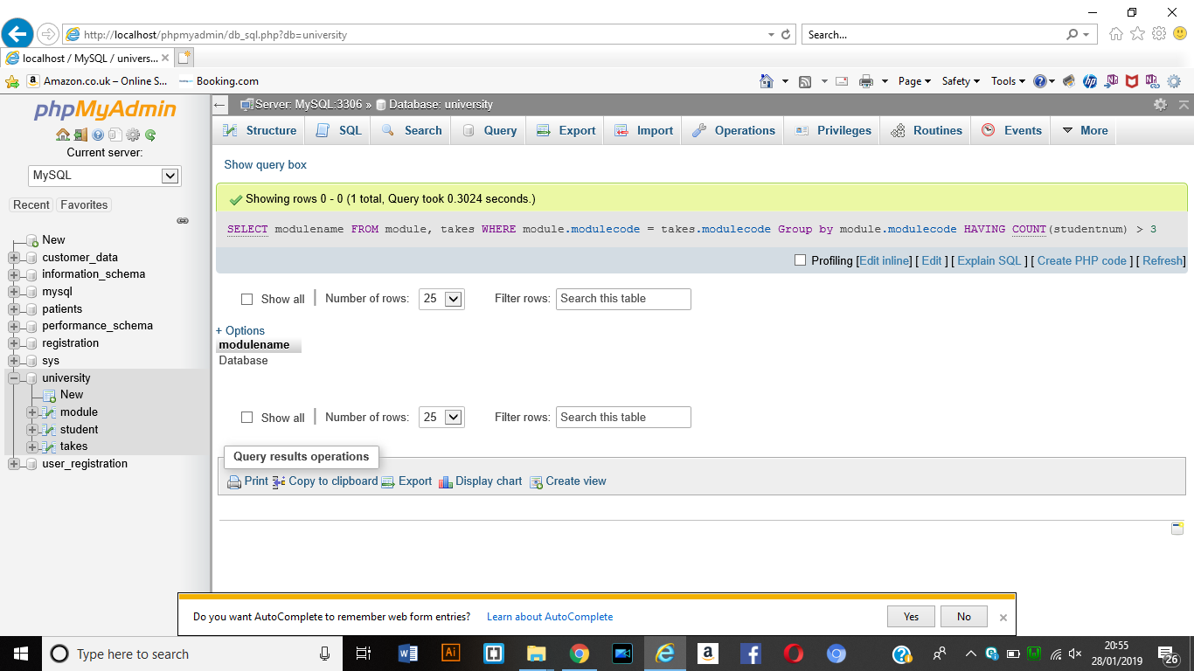

1. Get module names, which has the average age of students over 20.

SELECT modulename

FROM module, takes, student

WHERE module.modulecode = takes.modulecode

AND takes.studentnum = student.studentnum

GROUP by takes.modulecode

HAVING AVG(age) > 20;

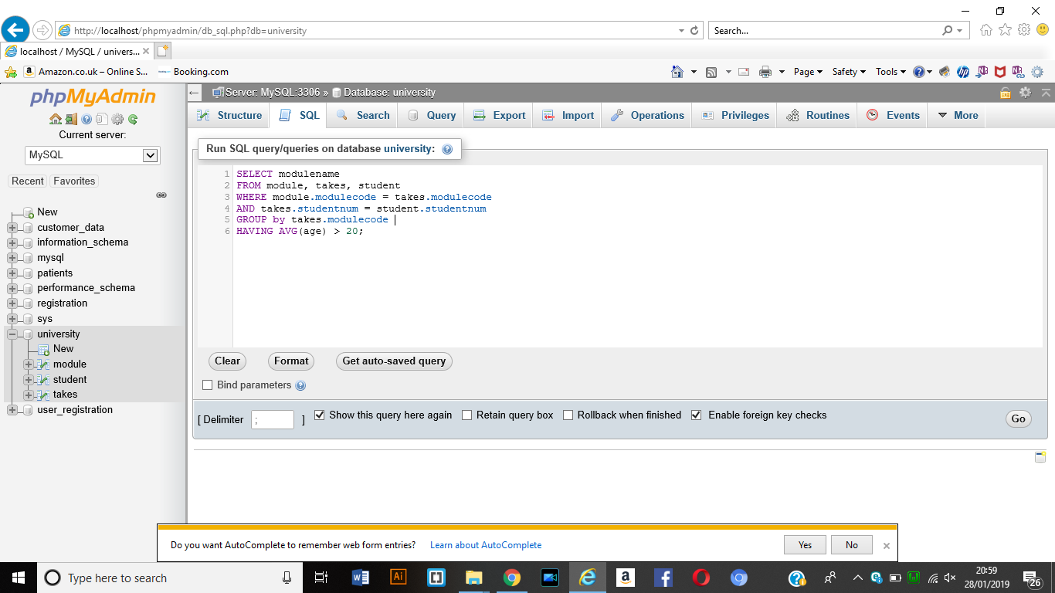

Result

